,Data visulation v/s business intelligent



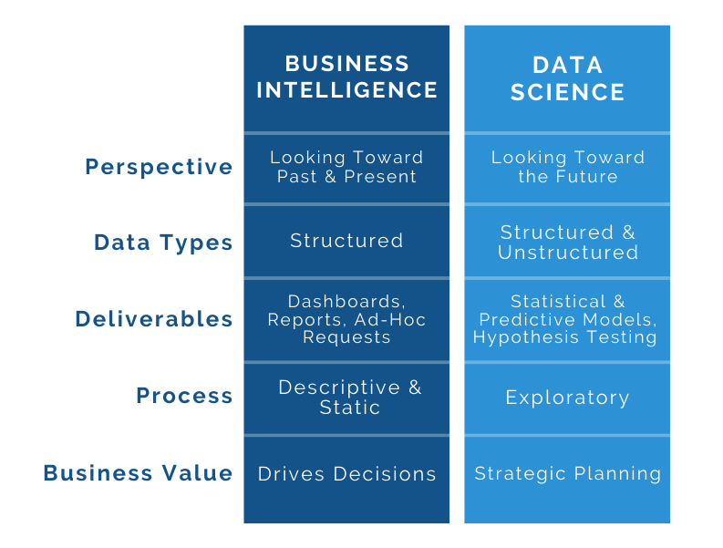

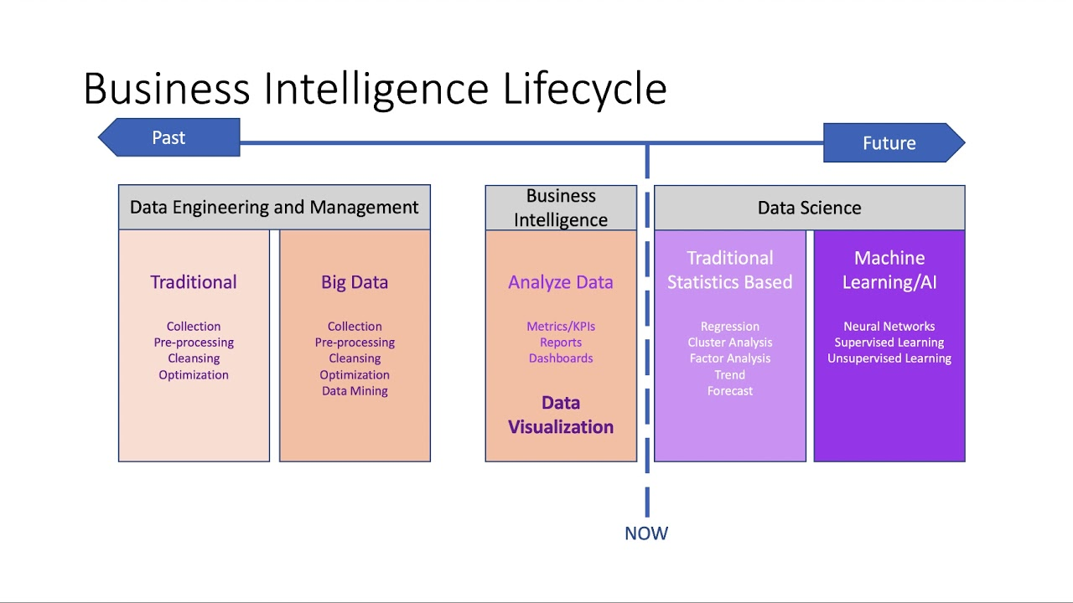

|  |  |
| --- | --- |
| Virat Kohli Profile - Age, Career Info, News, Stats, Records & Videos | Sachin Tendulkar:Biography, Birthday,Records,Education |
|  |  |

Tableau Version Public v/s Paid

* Tableau is free is fully functional with limitation of connectivity and saving
* Tableau desktop comes with a 14 days trial

Tableau download link

* https://www.tableau.com/products/public/download

Tableau file extension



* .twb
  + Only the Vizs, dashboard etc



**Tableau Workbook File (TWB)** is an XML document.

It contains the information about your sheets, dashboards and stories.

The TWB file references a data source file such as Excel or TDE, and when you save the TWB file, it is linked to the source.

The most important thing to remember about TWB files is that they don’t contain any data – if you want to share your workbook, therefore, you will need to send both the Tableau Workbook File and the data source file.

* .twbx
  + Workbook and the underlying extracted data



**Tableau Packaged Workbook (TWBX)** is a package of files “compressed” together.

It includes a data source file, TWB, and any other file used to produce the workbook (including images).

TWBX is intended for sharing. It does not link to the original file source; instead it contains a copy of the data that was obtained when the file was created. TWBX files are usually used as reports and can be viewed using Tableau Viewer.

TWBX isn’t designed for auto updating. If you refresh/update the source file, TWBX will stay unchanged. If you want your workbook to update when the source file is updated, you need to use the TWB file format.